**MAPÚA MALAYAN COLLEGES MINDANAO**

**FastTask**

Task Management System

In fulfillment of CPC2 M2 SA

**GAMUTAN, Adrian C.**

**2019102304**

**Computer Programming Concepts 2 - A126**

Course Professor

**Clyde Chester R. Balaman**

# TABLE OF CONTENTS

TITLE PAGE 1

TABLE OF CONTENTS 2

INTRODUCTION 3

SYSTEM DESIGN 4

DEVELOPMENT PROCESS 5

TESTING 6

CONCLUSION 8

REFERENCES 9

**Introduction**

FastTask is a transaction-based Java application which serves as a task management system for tasks and activities with a deadline. The application allows the user to input their current tasks along with their due date and times in which the application will keep track of remaining time left until the deadline. The idea of a task management application came from the many activities students do at school, having to keep up with assignments, projects, and quizzes and doing it all before their deadline. I myself am a repeat offender of forgetting due tasks and almost always passing activities late, this gave me an idea of creating an application where I can input the things I need to do and be able to manage the tasks easily.

The main objective of the application is to be able to provide a medium to display upcoming deadlines accompanied by the remaining time left before a certain task is due. This is done through creating a system for adding, managing, and sorting tasks. This can allow users to become more aware in their deadlines and tasks, giving reminders to overdue or nearly expiring tasks.

**System Design**

1. Overview

- **Application Name:** FastTask

- **Purpose:** Manage tasks efficiently with priorities, deadlines, search, and export capabilities.

- **Libraries:**

- Java Swing for GUI

- iText for PDF Export

- JCalendar for date picking

1. Architecture Diagram

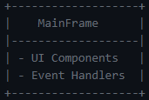

1. Component Diagram

**Development Process**

The application was created using NetBeans, using Java for Ant with utilization of Java Swing for the GUI, JCalendar for time, and iText for pdf export

**Features**

Task Management

* + Add new tasks with their name, due date, due time, and priority
  + Edit and update existing tasks
  + Delete tasks from list

Task Listing

* + Display added tasks with their respective columns (Priority, Task name, Due date, due time, Status (remaining time left))
  + Color-coded priority cells based on level of priority (low, medium, high)
  + Highlighted cells whenever a task is overdue
  + Real-time updating of remaining time left for due tasks

Search

* + Search tasks by name with real-time filtering

File Operations

* + Tasks are saved to a binary and text file when the application is closed
  + Tasks are loaded from the saved file upon opening application

Export to PDF

* + Added function to export list into pdf, sorted to a table

**Application Window Screenshot**

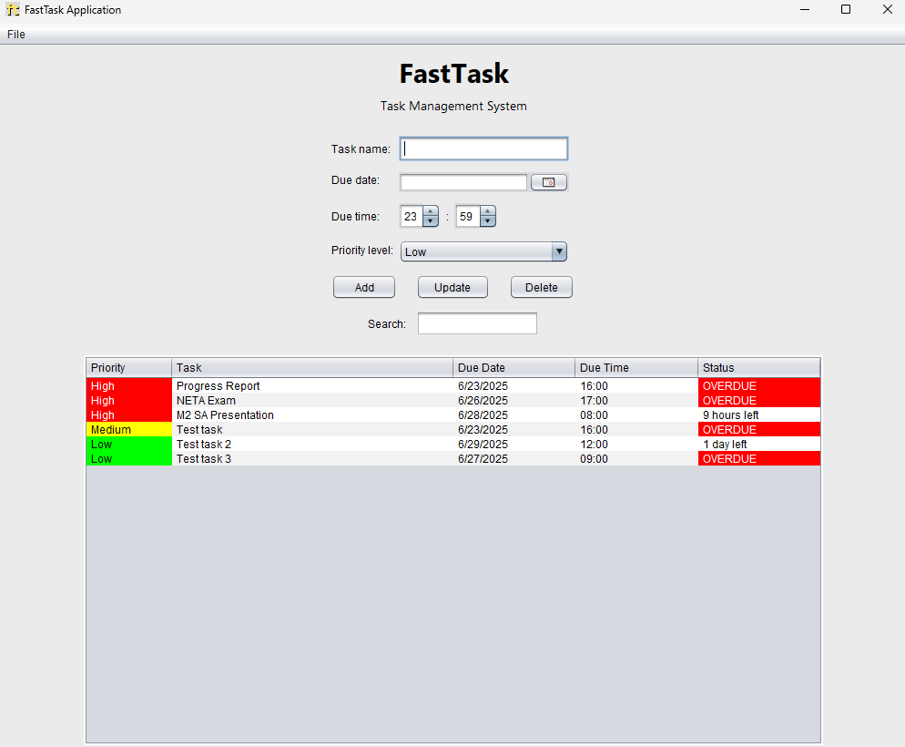

**Testing**

Adding task

Updating task

Deleting task

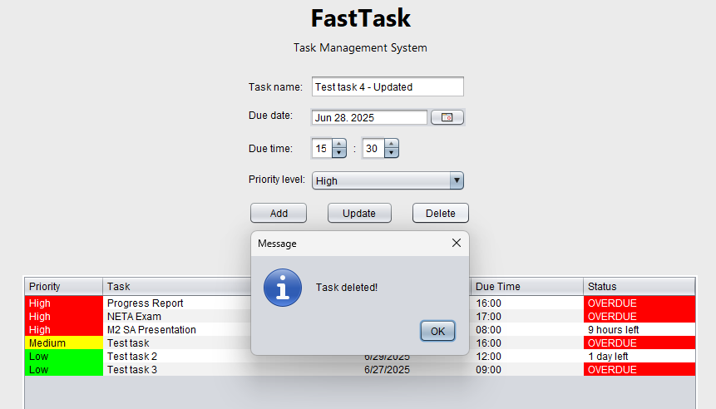

Search bar

Export to PDF

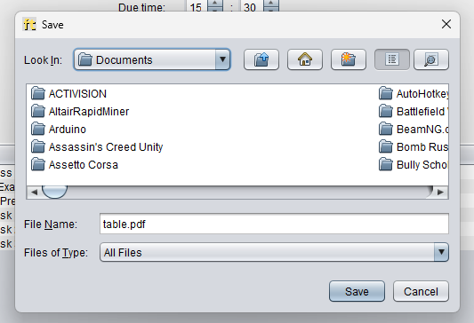

**Conclusion**

As a student that struggles to keep up with due tasks and passing on time, this application is basically a self-calling for me to improve on my time management skills. Coding and designing this program was very fun and challenging considering how I started out a bit late but I still managed to create a program that I can say I am proud of making. I have learned that creating plans for the project and scheduling weeks of singling out features helps out a lot in focusing certain parts of the program, which minimizes the stress as you know what you need to focus on for a certain week of the plan.

The features that I say could be improved in the program would definitely be the menu bar at the top, it would be better to have more features like opening and manually saving the table, as well as a shortcut key for such features. It would also be better if the format for the time was 12-hour instead of 24-hour. I planned on working on that feature, but it was too difficult for me to change after coding the events based on the format of the time. The overall look and design of the UI could also be improved on but for a simple task with simple intentions, it is not too bad. I would maybe focus more on a compact design much like the sticky notes app on Windows next time.

Overall, it was a very fun and meaningful experience that I can apply to my future learnings as I continue to finish my course as a CCIS student. I would like to thank Sir Clyde for his great patience despite my many shortcomings. I do not expect to win any awards for the presentation but I know that I had fun and that is what matters.

**References**

JCalendar: https://toedter.com/jcalendar/

iText: https://itextpdf.com/